Database Design for Ecommerce

For this e-commerce platform, I would like to choose for a Relational Database Management System (RDBMS) such as MySQL.

Reason For choosing RDBMS

1. structured nature
2. ability to handle complex relationships
3. ensure data integrity
4. Support Transaction

Entity Design

User Table:

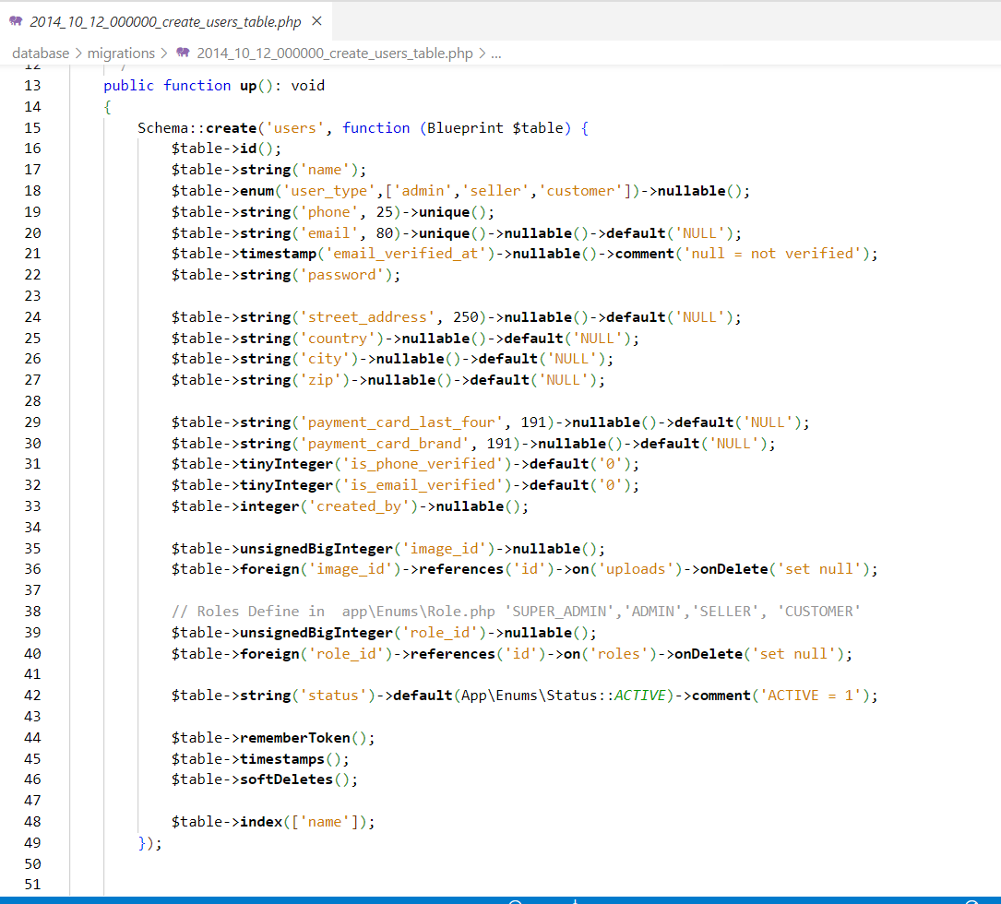

Products Table:

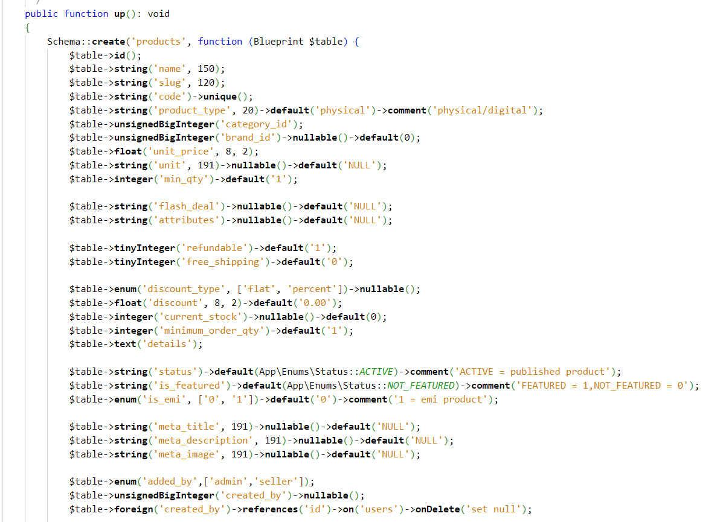

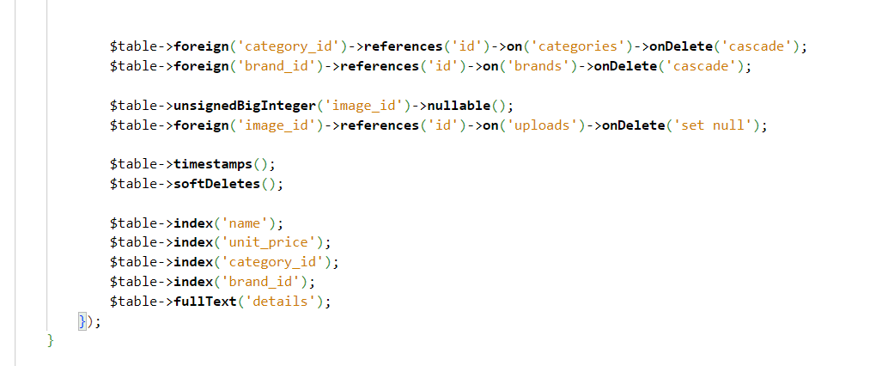

Category Table:

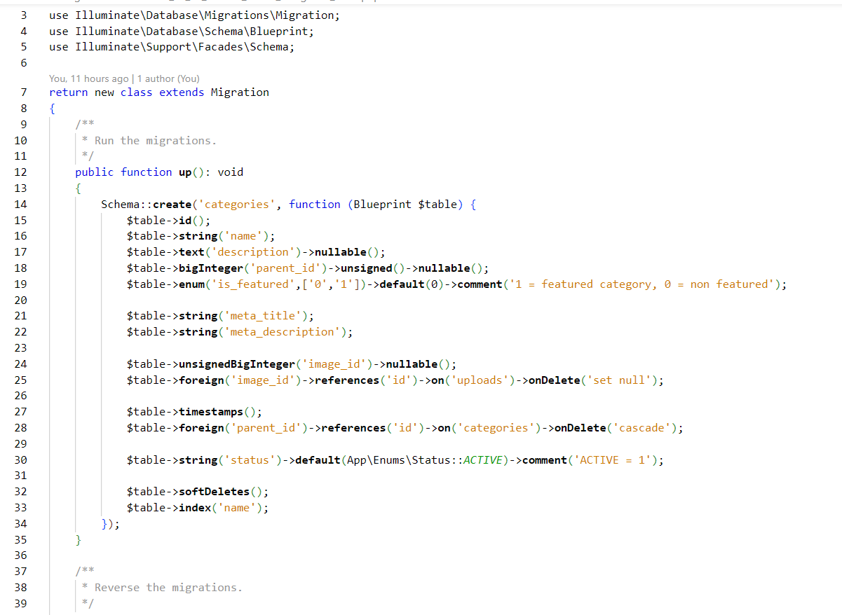

Order Table:

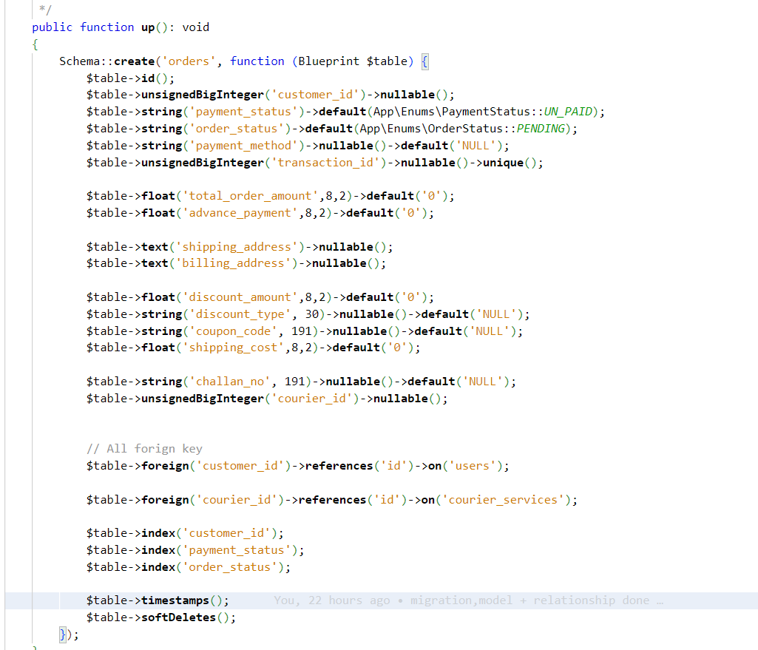

Order Details table:

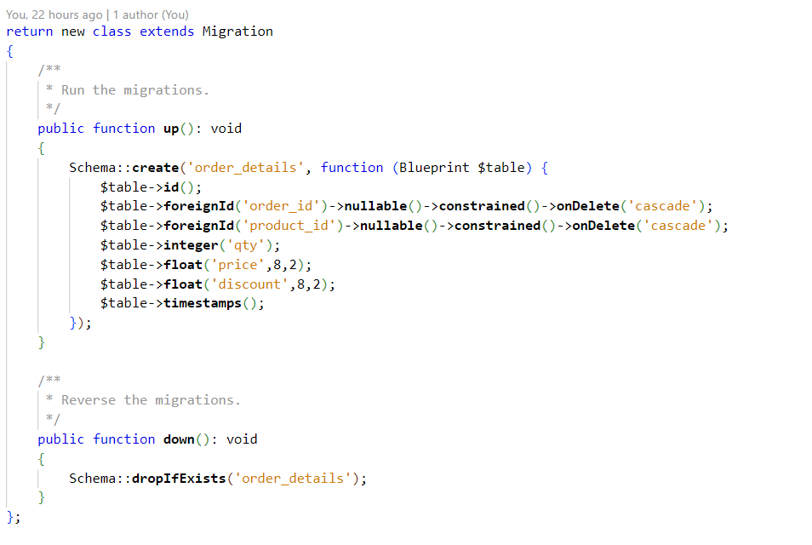

Transaction History Table:

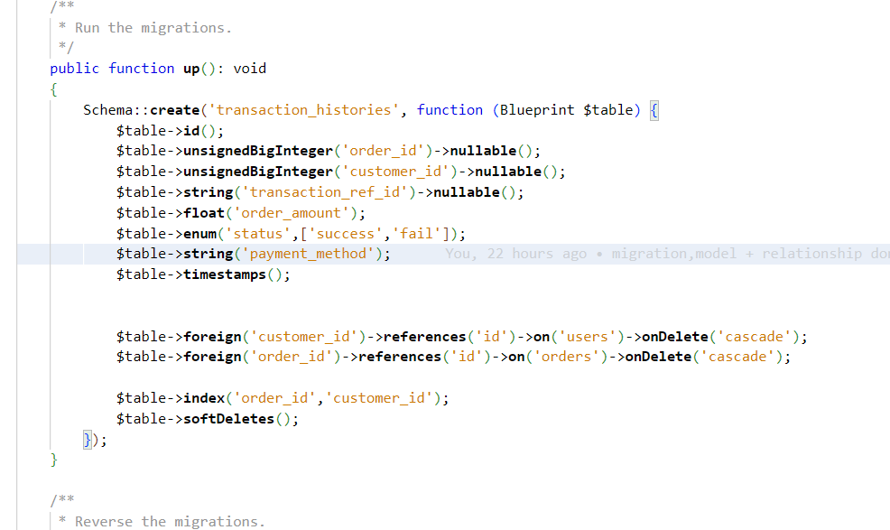

Roles Table:

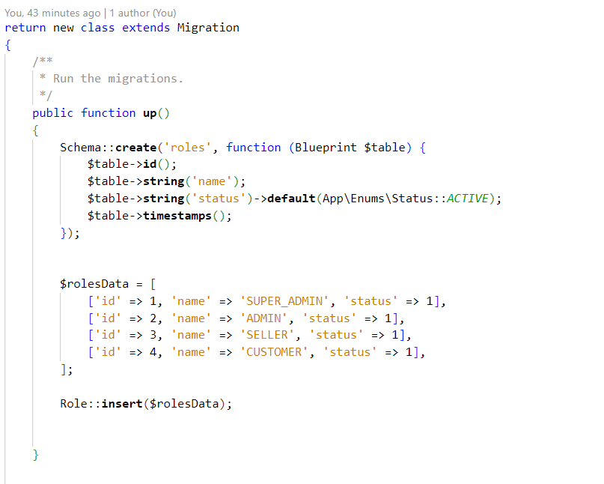

Brand Table:

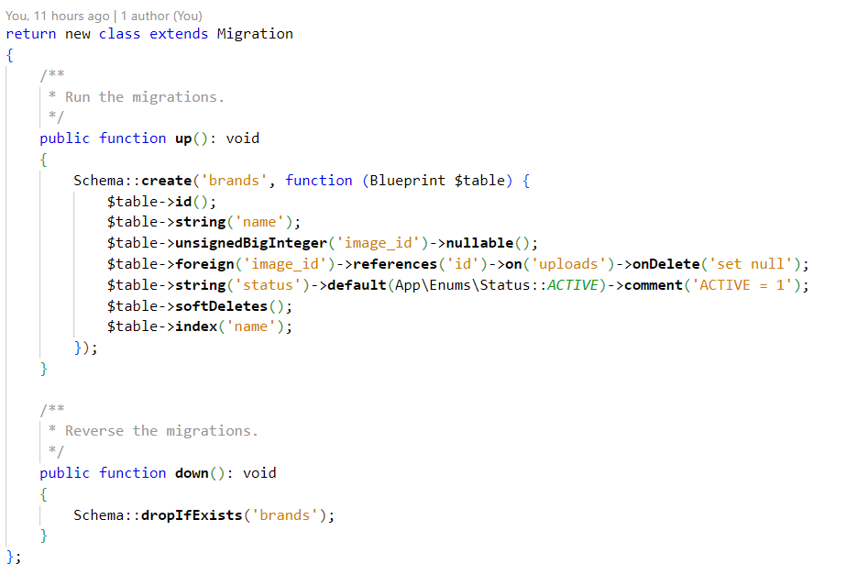

Cart Table:

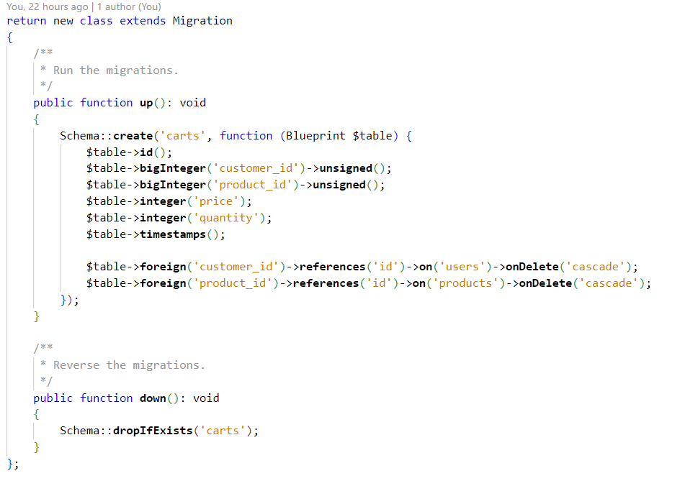

Role to Access table:

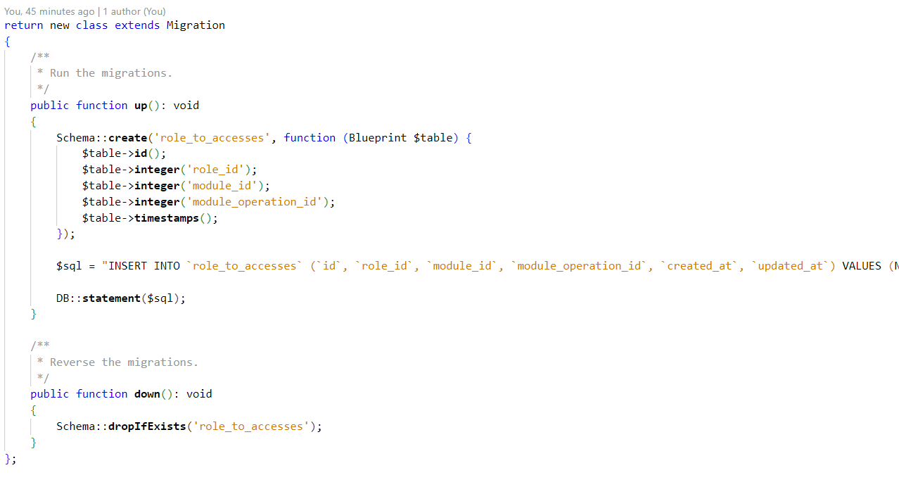

Code Directory: PROJECT\database\migrations

Relationship Between table

User table to other table:

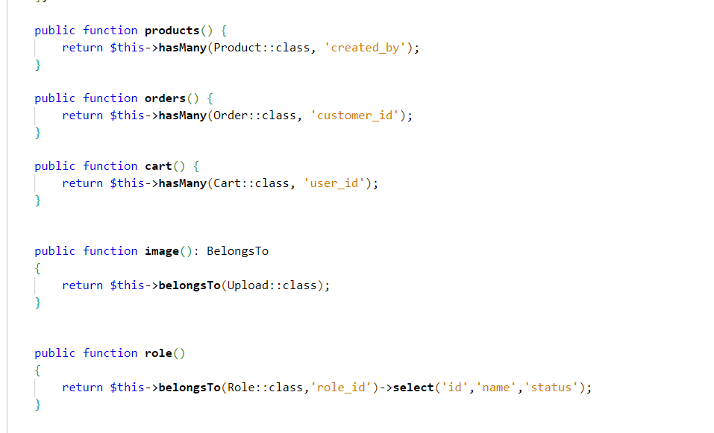

Product table to other table:

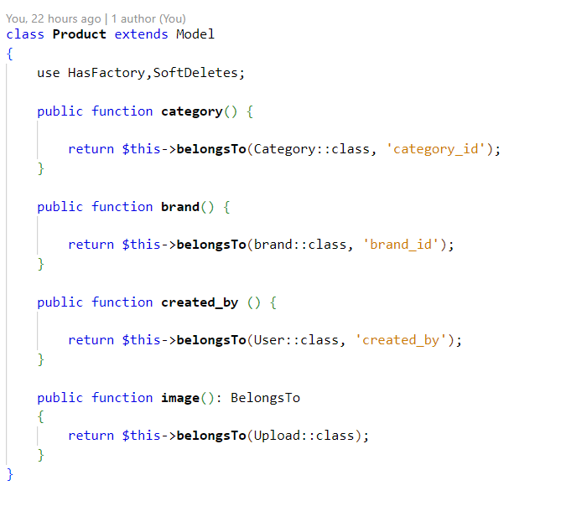

Category table to other table:

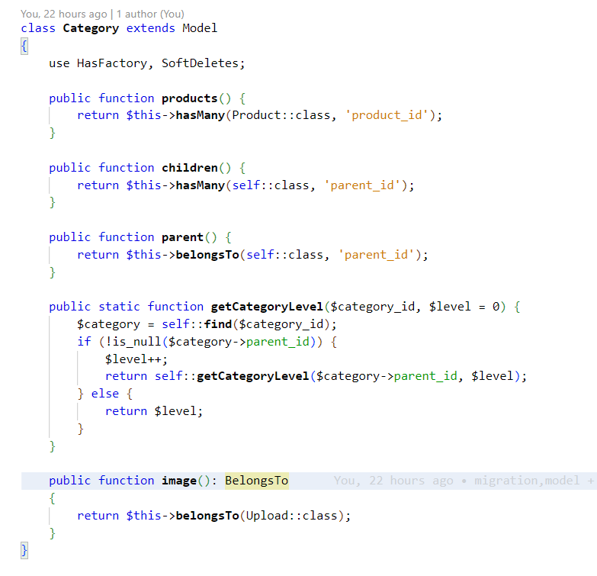

Cart table to other table:

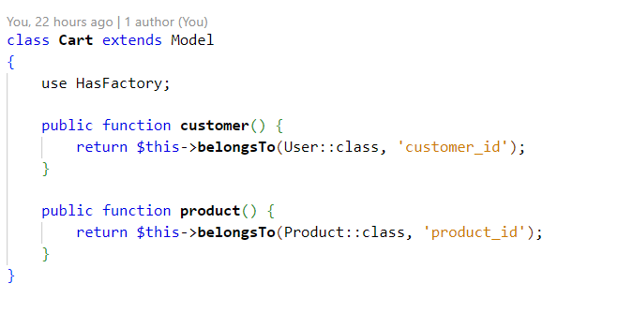

Order table to other table:

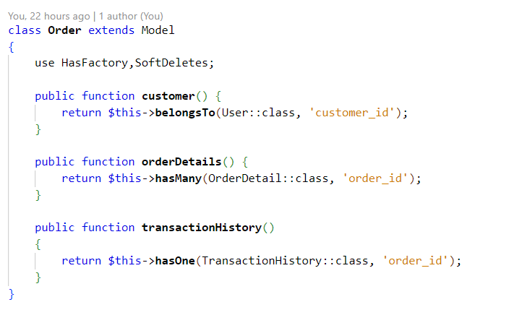

Order Details table to other table:

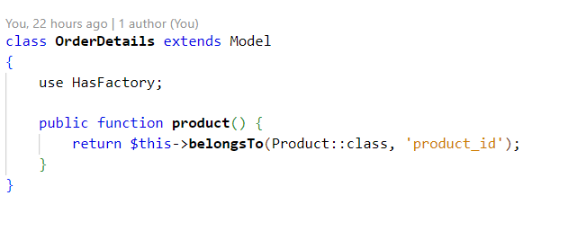

Transaction History table to other table:

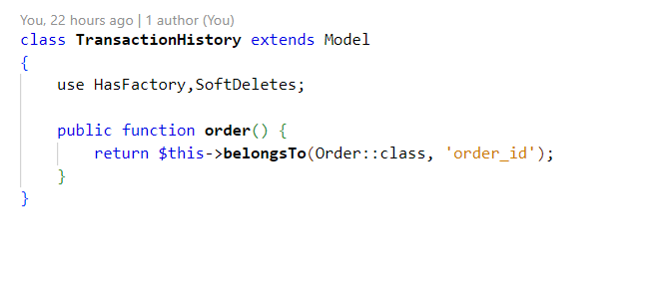

Brand table to other table:

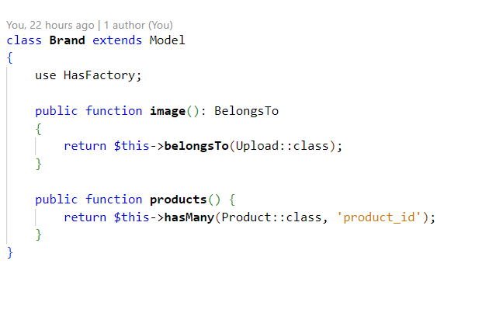

Code Directory: PROJECT\app\Models